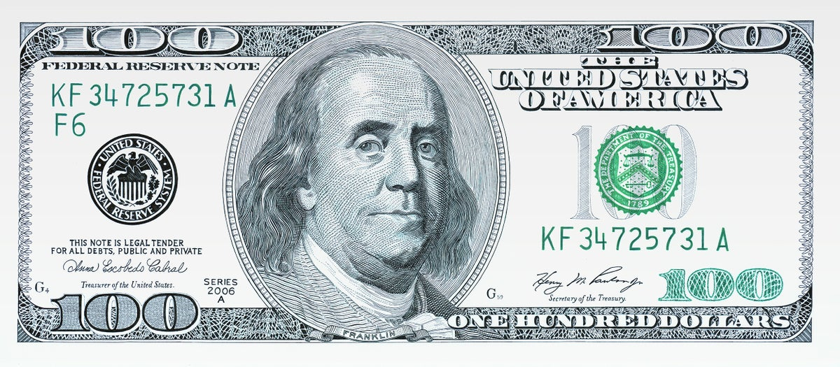

The dollar is the basic unit of United States money. It is worth 100 cents.
The dollar is also the main currency unit of: Australia, Canada, Jamaica, New Zealand, Singapore, Zimbabwe and some other countries.
The dollar was adopted in the USA in 1792. The first US dollars were issued in silver and gold. After 1934, however, all gold coins were taken out of circulation. A silver dollar was issued at various times from 1794 until 1935.
The dollar was adopted in Canada in 1878. Australia adopted the dollar in 1966, and New Zealand in 1967.

The dollar is the basic unit of United States money. It is worth 100 cents.
The dollar is also the main currency unit of: Australia, Canada, Jamaica, New Zealand, Singapore, Zimbabwe and some other countries.
The dollar was adopted in the USA in 1792. The first US dollars were issued in silver and gold. After 1934, however, all gold coins were taken out of circulation. A silver dollar was issued at various times from 1794 until 1935.
The dollar was adopted in Canada in 1878. Australia adopted the dollar in 1966, and New Zealand in 1967.

The dollar is the basic unit of United States money. It is worth 100 cents.
The dollar is also the main currency unit of: Australia, Canada, Jamaica, New Zealand, Singapore, Zimbabwe and some other countries.
The dollar was adopted in the USA in 1792. The first US dollars were issued in silver and gold. After 1934, however, all gold coins were taken out of circulation. A silver dollar was issued at various times from 1794 until 1935.
The dollar was adopted in Canada in 1878. Australia adopted the dollar in 1966, and New Zealand in 1967.

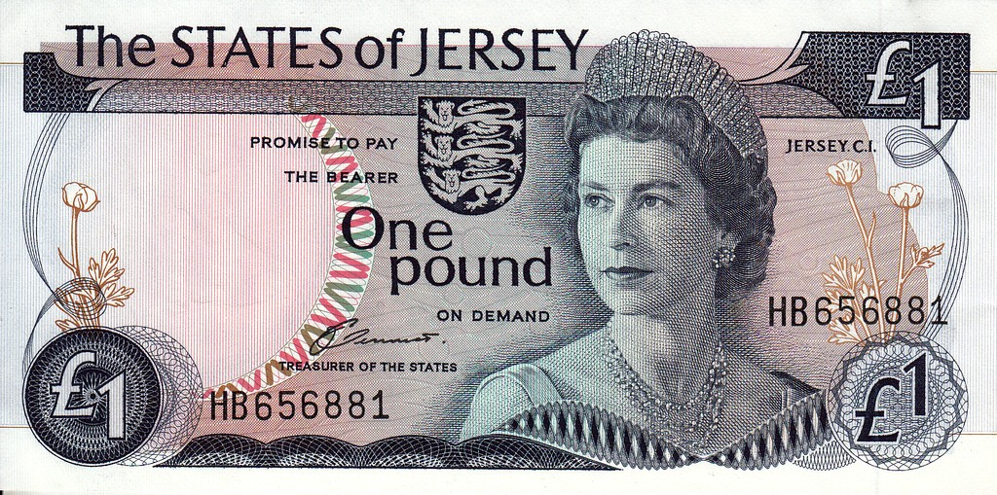

The basic unit of money of the United Kingdom is the pound, also called the pound sterling. Today the pound is equal to 100 pence. the British adopted the decimal system in 1971.
Things were far more complicated in the past. The pound was subdivided into 20 shillings. The shilling was subdivided into 12 pennies. The guinea was equal to one pound one shilling. It was a gold coin used in fixing prices of valuable goods. There also were crowns, 5 – shilling silver coins; halfcrowns worth 2 shillings and 6 pence; florins, 2 – shilling silver coins; bobs worth 12 pence. a sixpence was a 6 – penny coin and a 3 – penny coin was called a “threepence”. There also were “ha’pennies”, copper coins, worth half a penny, and farthings, or quarter – penny coins.

The basic unit of money of the United Kingdom is the pound, also called the pound sterling. Today the pound is equal to 100 pence. the British adopted the decimal system in 1971.
Things were far more complicated in the past. The pound was subdivided into 20 shillings. The shilling was subdivided into 12 pennies. The guinea was equal to one pound one shilling. It was a gold coin used in fixing prices of valuable goods. There also were crowns, 5 – shilling silver coins; halfcrowns worth 2 shillings and 6 pence; florins, 2 – shilling silver coins; bobs worth 12 pence. a sixpence was a 6 – penny coin and a 3 – penny coin was called a “threepence”. There also were “ha’pennies”, copper coins, worth half a penny, and farthings, or quarter – penny coins.

The basic unit of money of the United Kingdom is the pound, also called the pound sterling. Today the pound is equal to 100 pence. the British adopted the decimal system in 1971.
Things were far more complicated in the past. The pound was subdivided into 20 shillings. The shilling was subdivided into 12 pennies. The guinea was equal to one pound one shilling. It was a gold coin used in fixing prices of valuable goods. There also were crowns, 5 – shilling silver coins; halfcrowns worth 2 shillings and 6 pence; florins, 2 – shilling silver coins; bobs worth 12 pence. a sixpence was a 6 – penny coin and a 3 – penny coin was called a “threepence”. There also were “ha’pennies”, copper coins, worth half a penny, and farthings, or quarter – penny coins.

