1 раздатка (7 листов)
R N E O A G -
P L A P E –
R A B E D –
I H F S-
R N E O A G -
P L A P E –
R A B E D –
I H F S-
R N E O A G -
P L A P E –
R A B E D –
I H F S-
R N E O A G -
P L A P E –
R A B E D –
I H F S-

2 раздатка (7)
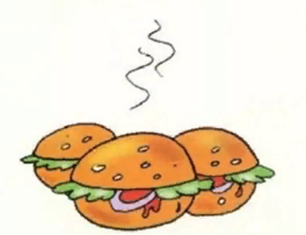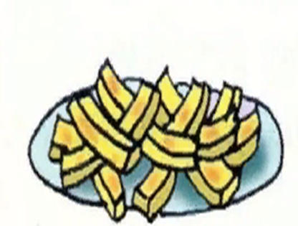
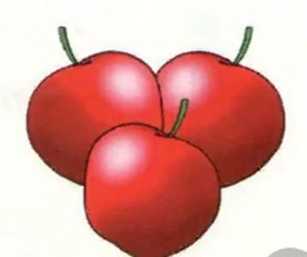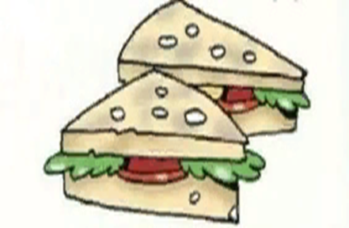
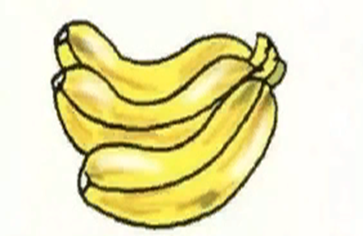

3 раздатка (7 листов)
Gburer_____________________ Bnaaan____________________ Cpshi______________________ Swicandh___________________ Pleap______________________
Gburer_____________________ Bnaaan____________________ Cpshi______________________ Swicandh___________________ Pleap______________________
Gburer_____________________ Bnaaan____________________ Cpshi______________________ Swicandh___________________ Pleap______________________
Gburer_____________________ Bnaaan____________________ Cpshi______________________ Swicandh___________________ Pleap______________________

4 раздатка (3 листа)


